Shapefiles for R Programmers

<http://courses2.arilamstein.com/enrollments>

# Introduction

SF Board of Supervisors page: <http://www.sfbos.org/>

SF Open Data: <https://data.sfgov.org/>

SF Supervisors district map: <https://data.sfgov.org/Geographic-Locations-and-Boundaries/Supervisorial-Districts-as-of-April-2012/xz9b-wyfc>

SF 311 Data (with Supervisors District column): <https://data.sfgov.org/City-Infrastructure/Case-Data-from-San-Francisco-311-SF311-/vw6y-z8j6>

# Shapefiles in QGIS

"A Gentle Introduction to GIS": <http://docs.qgis.org/2.8/en/docs/gentle_gis_introduction/index.html>

1. Main QGIS page: <http://qgis.org>

QGIS download page: <http://qgis.org/en/site/forusers/download.html>   
I believe this link is old. Just go to main QGIS page.

# Shapefiles in R

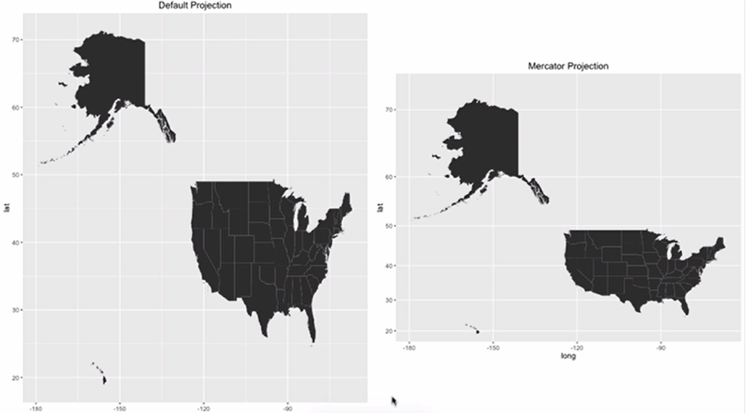

# Choropleth Maps with ggplot2

# Choropleth Map with Choroplethr

Makes it easier to create choropleth maps in R

1. Create Choroplethr Object
2. Creating the map
3. Changing colors
4. Adding a reference map
5. How to zoom
6. Encapsulation